There are two ways for students to access the evaluation from mylearn (screenshots below).

- mylearn homepage – students can access the RU feedback evaluation from the homepage within the “my transcript” box. Students will locate the session they need to evaluate, select evaluate and then take the survey.

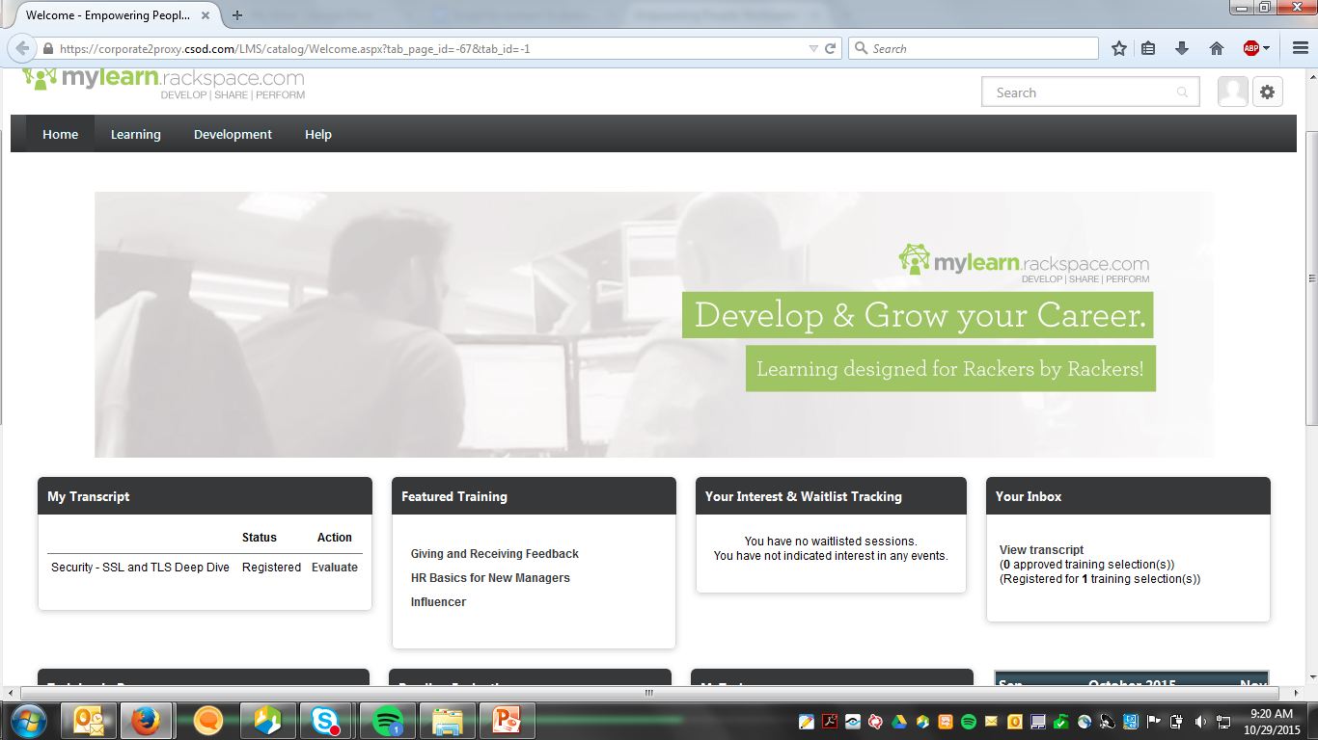

- mylearn transcript – students can access the RU feedback evaluation from their transcript in mylearn. To get to their transcript students need to follow thw following steps:
  - Click their face in the upper right hand corner of the homepage
  - Select transcript on the left hand side of their profile page
  - Find the session that they wish to evaluate
  - Click the down arrow next to “view training details”
  - Select evaluate

